**EECS 481 Software Engineering**

**Use Case and Sequence Diagrams**

**Team SET: Anthony Chiang, Bryant Ku, Steven Louie, Mark Mevorah, Deng Ke Teo,**

**Jason Terranova, Steven Uy**

**Use case diagram**

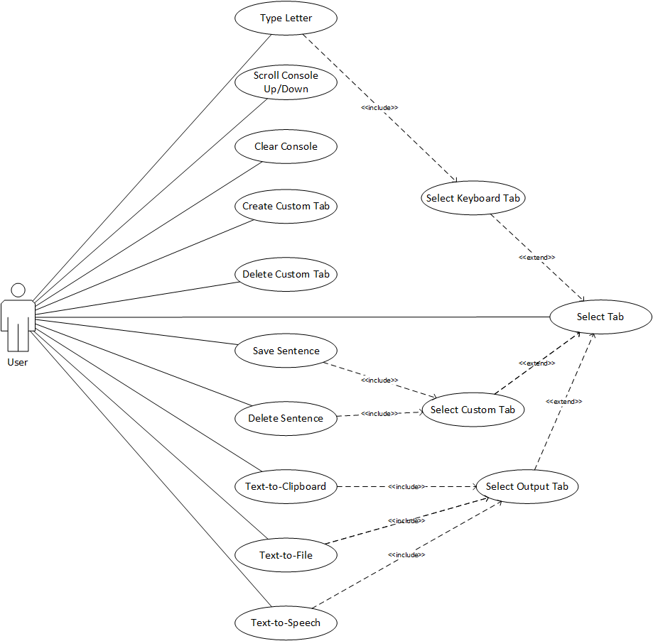

*Figure 1: Main use case diagram*

**Use case description** The SET keyboard application is directed towards people with disabilities that inhibit their ability to physically and verbally communicate. Users use the application's eye tracking capabilities to type characters via the QWERTY or T9 keyboard. A tab controller organizes the application as a whole. This enables keyboard types, output options, and stored sentences to live within separate tabs within the application providing the user with an intuitive user interface. More details regarding the semantics of eye tracking input can be found in the requirements definition section of the project scope.

When a user launches the application, they are met with a GUI consisting of a console, a QWERTY keyboard, and a tab controller. The console contains buttons to allow for scrolling, in the event that there was a text overflow. Furthermore it has a button to clear its text. The QWERTY keyboard is one of two keyboards the user can interact with, both accessible through a tab selection bar. An output tab exists as well, providing the ability to output what is on the console via text to file, text to speech, or text to clipboard. Other tabs can be created or deleted by the user. These tabs are referred to as "custom tabs," and contain blocks of user-stored sentences that can be used at a later time. These stored sentences can be added or deleted at the users will.

Text input involves holding focus on a specific key for a certain amount of time. The selected key character is then appended to the text in the console. Word completion then displays a list of predictions below the console, allowing the user to select a completed word. When a word is completed, predictions for the following word will appear below the console. Again, the user is able to select a word to be appended to the text in the console.

**Sequence diagrams**

The figures below are the sequence diagrams representing multiple interactions.

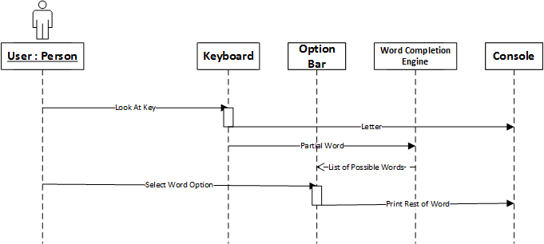

*Figure 2: “Type letter” sequence diagram*

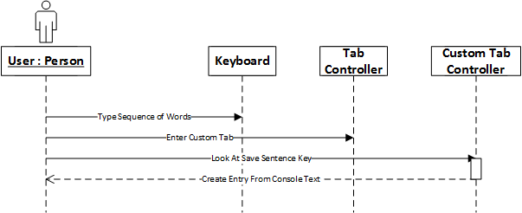

*Figure 3: “Save sentence” sequence diagram*

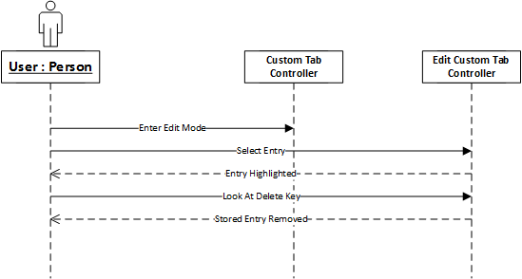

*Figure 4: “Delete stored sentence” sequence diagram*

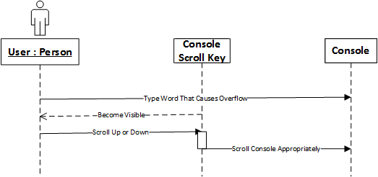

*Figure 5: “Scrolling console” sequence diagram*

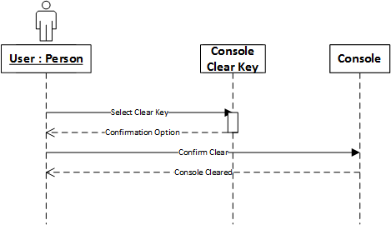

*Figure 6: “Clear console” sequence diagram*

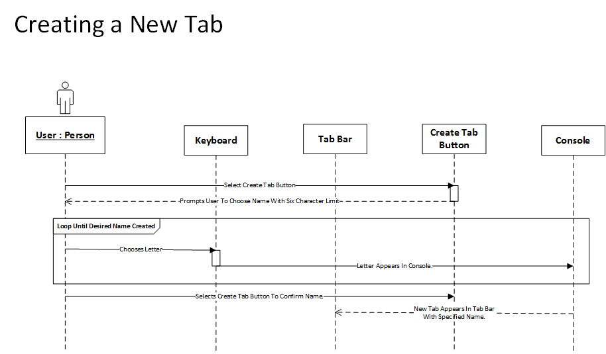

*Figure 7: “Create tab” sequence diagram*

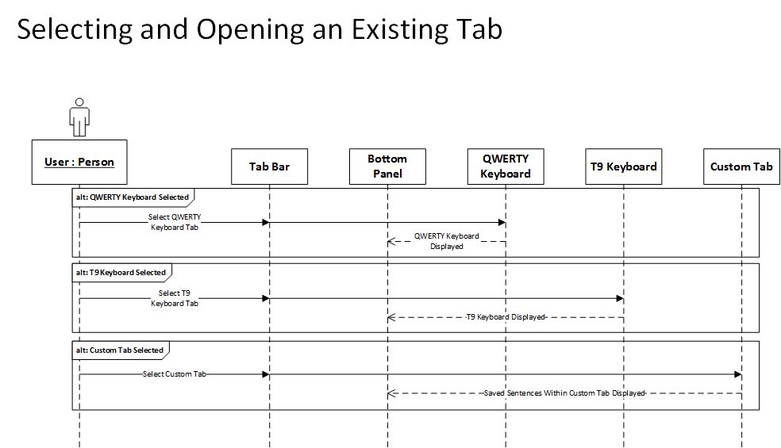

*Figure 8: “Select tab” sequence diagram*

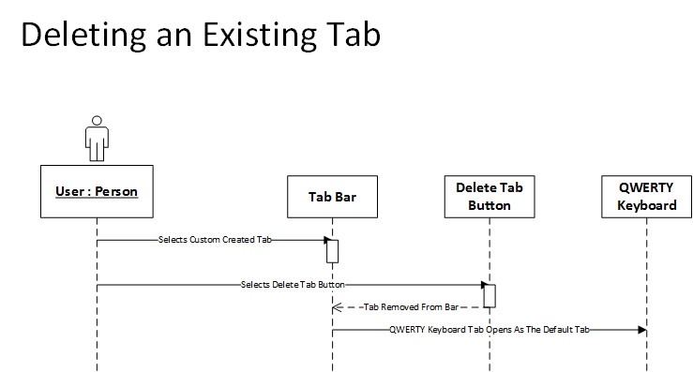

*Figure 9: “Delete tab” sequence diagram*

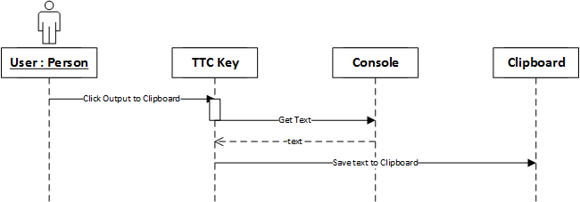

*Figure 10: “Text to clipboard” sequence diagram*

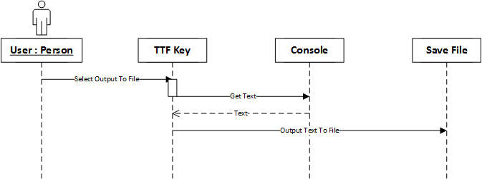

*Figure 11: “Text to file” sequence diagram*

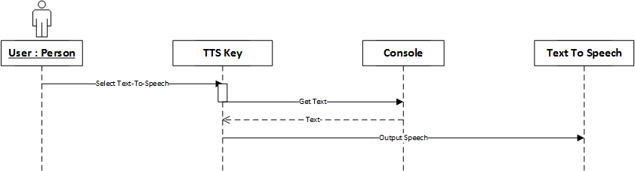

*Figure 12: “Text to speech” sequence diagram*

**References**

*[1]Microsoft Vizio 2013. Microsoft.<*[*http://office.microsoft.com/en-us/visio/*](http://office.microsoft.com/en-us/visio/)*>*